Children can cook too!

Give the kids a cooking recipe and let them cook! It's an easy recipe to make fruit on a stick. In Belgium we call it 'fruitsaté'. The cooking recipes are with images of different fruits. They have to count how much to cook. They have to prick the fruits on a stick, tell it to the children. Under the recipe they can find the order of pricking the fruit. You can give pre-cut fruit. But let them try to cut a fruit themselves, and let the children easily cut fruit, such as banana. Do not be afraid, give the children blunt knives. Tell them that a knife is dangerous, and they should use it safely. This is a good exercise for counting and fine motor skills. The exercises is also good for visual training, They learn the similarity between a photo and reality. And at least they have a healthy snack! (the recipe does you find under this picture)

This is a fruitsaté

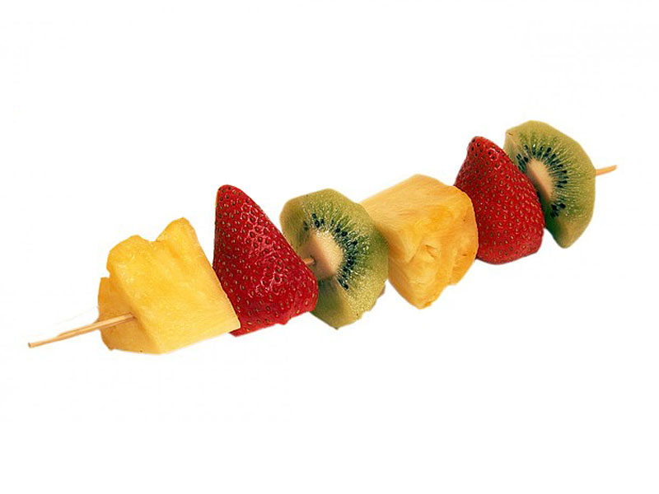



Cooking recipe for children



